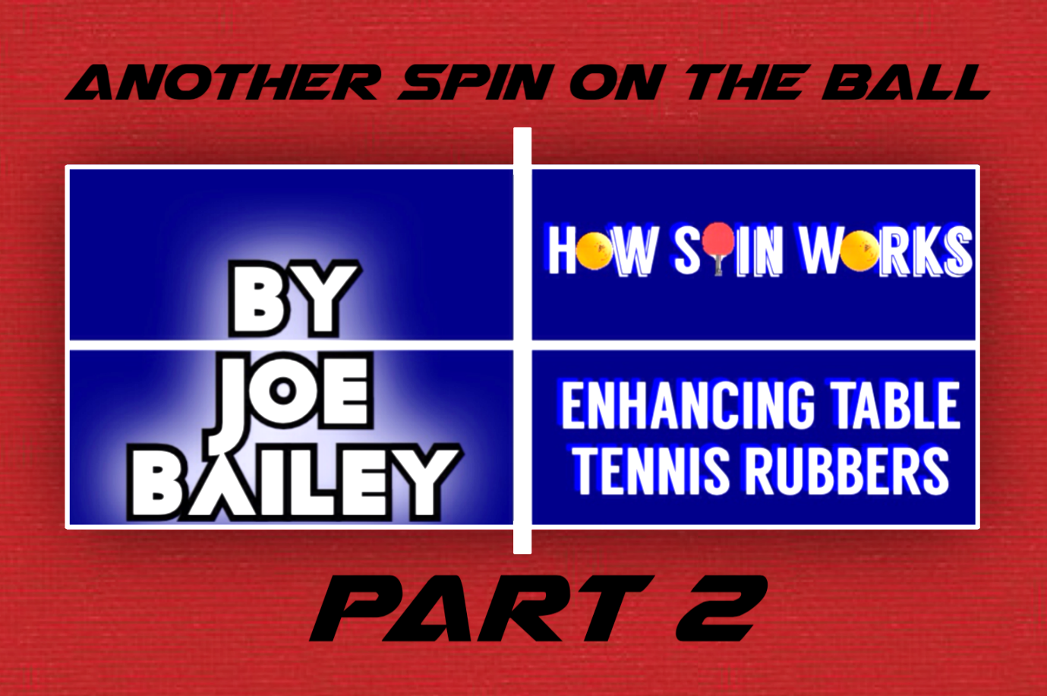
4

[Document title]
¹In table tennis, power, or speed, is defined by a racket’s efficiency of restitution.
Hutchins, YEAR 10 SCIENCE:
RESEARCH INVESTIGATION
Does cleaning a table tennis racket and keeping it in a case preserve its power¹ and spin?
Title Question:
Does cleaning a table tennis racket and keeping it in a case preserve its power and spin?

Introduction:
Spin plays a large part in most, if not all, ball sports. In no sport is the Magnus Effect more conspicuous than in the sport of table tennis. The small, light ball can spin up to 150 revolutions per second in a match situation. (Qun, et al., 1992) This is due largely to technique, but the level of spin has greatly increased since the 1950s, due to the invention of “sandwich rubber”, or “Inverted rubber” (see Figure 1), as opposed to the old pimpled rubbers (Figure 2). This greatly increased surface area and spin, and so it changed the sport and history, as players now looked to optimise the spin of their rackets. After years of playing with glues to change the sponge thickness, and the consequential banning of certain glues, players realised that rubbers were getting expensive, and after the banning of substances other than water to clean the racket, many club-level and recreational players wondered if cleaning the racket was still beneficial. As I found in How Spin Works (Bailey, 2014), various substances can increase the spin of the racket, but to what degree does water preserve it? And it is worth keeping the racket in a case, and how does this apply to the average competitive and recreational player? An average club player will often replace rubbers once or twice a year, with many rubbers costing up to $90 each. This can add up to $360 a year in equipment very quickly. More serious players will often change rubber every three or four months – so preserving rubbers for a few weeks could both save players fortunes worldwide and also greatly reduce the worldwide consumption of natural and synthetic rubbers.
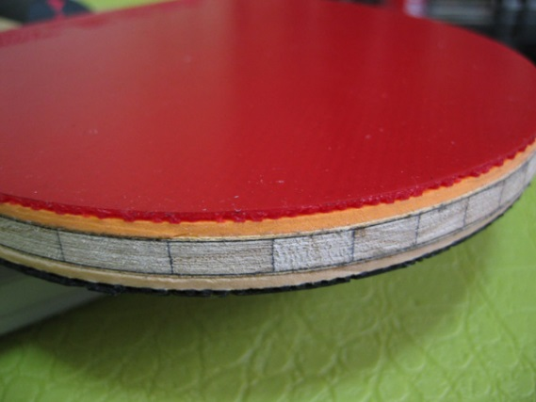
Figure 1:
The red part is called the topsheet.
Under that is the sponge, which is glued to
the wooden blade.
(Pingpongkf, 2006)

Figure 2:
Note the pimples are on the outside of the
rubber, and the lower contact area of the ball,
meaning there is less spin.
(Haggisv, 2010)

Abstract:
This experiment was conducted to find if cleaning a table tennis racket and keeping it in a case preserved its power and spin. Through the use of a bounce efficiency test and a spin test to measure the angle of reflection (using a ball launcher), it was found that cleaning a racket and keeping it in a case does preserve the racket. On low-level competition equipment, the difference is noticeable, but on lower-level recreational equipment, the difference is likely unnoticeable for a recreational player.

Objective:
To find the effects of cleaning methods of a table tennis racket on the racket’s playing characteristics power and spin.

Background:
As found in How Spin Works Part 1 (Bailey, 2014), the three major characteristics that affect the power and spin of a rubber are:
- Hardness. This obviously plays the main role in the power test, but the hardness (particularly of the topsheet) also plays a major role in the spin that the racket is able to produce. This is because the softer the rubber is, the surface area that contacts the ball is increased, thus there is more friction.
The elasticity is closely related to the hardness of the rubber. Many rubbers are stretched in the factory, and are sold as ‘tensor’ rubbers. These achieve more power by acting as a trampoline; the rubber compresses, and ‘springs’ back into shape, providing more power. Tensor rubbers have a similar effect on spin, much like when a spinning rubber ball bounces, and the spin reverses. The rubber of the ball stretches while contacting the ground, and springs back into place, reversing the spin. However, in the case of a table tennis rubber the tangential stretch of the rubber due to the spinning ball, coupled with the movement of the racket against the spin (increasing this stretch), the rubber returns to its natural state, imparting a great deal of spin on the ball.

- Tackiness. The tackiness (or stickiness) can affect the power of the racket, as the bounce is reduced by the racket’s tendency to ‘hold on’ to the ball. Tackiness has a larger influence on spin than hardness of the rubber, as a slippery surface could have a greater contact area, but the ball would not grip. The tackiness provides a point for the ball to momentarily stick to and therefore be turned by the racket (known as topsheet spin), as opposed to the mechanical spin produced by the return to shape of the rubber.
- Smoothness. Though smoothness does not affect power or spin as much as the hardness (and elasticity) or the tackiness (and grip), the smoothness plays a part in the contact area of the ball. If there is a large amount of dust, for example, on the bat, then not only would the dust cover parts of the rubber that grip the ball more, but the dust would also make the surface uneven, and if parts of the rubber are covered in dust, then that area is contacting the dust, not the racket, thus reducing the contact area of the rubber.
Why the throw angle changes with differing amounts of spin:
When a spinning ball hits the racket, one side of the ball is travelling (relative to the other side) faster. This is because (relative to the centre of the ball), one side is travelling forwards, and the other backwards. When the ball makes contact with the racket, the ball grips to the racket. This means a certain point of the ball stops, as the ball begins to turn away from the racket, as the ball naturally keeps spinning (due to inertia). Because this ball has gripped, the angle of reflection changes, becoming what is known as the throw angle.

Hypothesis:
Cleaning a table tennis racket and keeping it in a case will significantly preserve its ability to impart power and spin on a ball. Leaving a racket in the sun will severely decrease its ability to create both spin and power.

Risk Assessment:
There are no particularly dangerous items used in this experiment, but table tennis balls will be launched at high speeds, so common sense around the equipment is required to prevent injuries caused by slipping on table tennis balls or similar injuries.

Apparatus:
5 Regail brand table tennis rackets were used as tested rubber surfaces.
3 star (top quality) ITTF Approved Double Fish table tennis balls were shot at the rackets.
1 Double Fish Ball-Launching Table Tennis Robot fired the balls towards the racket with topspin.
1 Casio camera (capable of filming at 240fps) was used in recording the data.
1 90-degree brace to hold the rackets at a 90-degree angle.
1 rubber band to hold the rackets to the brace.
1 Metre rule was used as a scale for data analysis in Vernier Logger Pro and Vernier Video Physics.
1 protractor was used to measure the throw angle (supported with calculations).

Procedure:
1. First, with an old bat, the robot was set up on full topspin and the equipment was moved around to find the optimal position for the equipment in order to record accurate data. An outline of the equipment was drawn on the table (similar to a shadow board) to ensure the equipment could be moved back into position if it was bumped or moved.
2. Once the positions were established, there were two separate tests to conduct; one for each playing characteristic.
3. All of the rackets were tested at first (without treatment) to ensure they all had similar results in both power and spin.
4. Each week, one day before tests, each racket would have exactly 50 shots played with it, to accelerate the degradation of the rubber. Immediately afterwards, the two rackets to be cleaned would be lightly wiped over with a wet sponge.
5. The tests were repeated at exactly 3:30pm every Sunday, every week.
Variables:
- Racket 1 was cleaned once a week and kept in a case when not in use (testing or 50 shots).
- Racket 2 was kept in a case, but was not cleaned.
- Racket 3 was cleaned, but not kept in a case.
- Racket 4 was the control, and was not cleaned, nor was it kept in a case.
- A fifth racket was kept in a different position, which was subject to approximately 1 hour of sunlight a day. This racket was not cleaned, nor was it in a case.
The independent variables were therefore the cleaning and storing methods, and the dependent variables were power and spin.
The Power Test:
The power test was a simple bounce efficiency test. The ball was dropped from a level platform with 300mm elevation from the top of the racket, and the rebound was filmed from two angles (to eliminate parallax error) and repeated ten times to find the average rebound height (outliers omitted). This was repeated for each racket.
The Spin Test:
The spin test was a much more involved test. First, the robot was set up to full topspin, while the racket was attached to a 90-degree base by rubber band. The robot would then fire ten shots towards the racket, while the camera filmed its rebound. The rebound was then analysed to calculate the throw angle. Note the throw angle (a table tennis term) is the angle of reflection (as opposed to the angle of incidence, which was kept constant). A racket which has an angle of reflection greatly affected by incoming spin (due to friction – i.e. more spin) is said to have a high throw. The ten rebounds were then averaged out (outliers omitted) to find the average angle of reflection.
Calculations:
The final results for each test followed this procedure:
- The video (with locations points recorded) was uploaded into Vernier Logger Pro.
- (Power): The scale was then set by the height of the ruler equalling (x) amount of pixels. The rebound height in pixels was then automatically calculated by the software to give a result in millimetres.
- (Spin): The position-graph would have its axes manipulated so that the x-and y-axes were equal (so the ratio was 1:1 – giving a scale representation of the actual rebound) and the angle of incidence was recorded with a protractor, as was the angle of reflection. The angle of incidence was then subtracted from the angle of reflection to find the throw angle (the increased angle due to spin).
- To confirm the results of the spin test, the coordinates of several points were recorded. The distance between points were then calculated through Pythagoras’ Theorem, and then by the use of Trigonometry (the Cosine rule – (side, side, side)), the angles of the triangles were found.
- The ten angles of the rebound were then averaged (outliers omitted) to find the final result for each bat every week.
Data: A sample of the data spread (racket 1, week 10, power and spin respectively).
 | Test 1 | Test 2 | Test 3 | Test 4 | Test 5 | Test 6 | Test 7 | Test 8 | Test 9 | Test 10
Power (mm) | 172 | 174 | 170 | 171 | 173 | 174 | 170 | 171 | 172 | 173
Spin (throw angle) | 26.5° | 24° | 25° | 24° | 24° | 25° | 25° | 26° | 24° | 25°
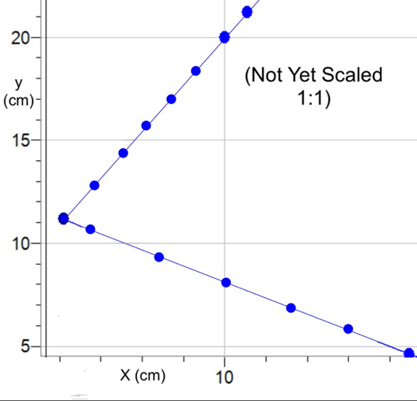
Example of a trajectory graph, including rebound from which the angle of reflection was measured (sample from racket 1, week 10):
Figure 3:

Week 1 compared to Week 10:
Table 1 | Racket 1 | Racket 2 | Racket 3 | Racket 4 (control) | Racket 5
Week 1 power | 201mm | 199mm | 202mm | 201mm | 200mm
Week 10 power | 172mm | 157mm | 162mm | 153mm | 148mm
Week 1 spin | 27.1° | 26.8° | 27° | 26.9° | 27.1°
Week 10 spin | 24.85° | 21.2° | 22.3° | 19.4° | 17.0°

Racket Photo Comparison (Table 2)
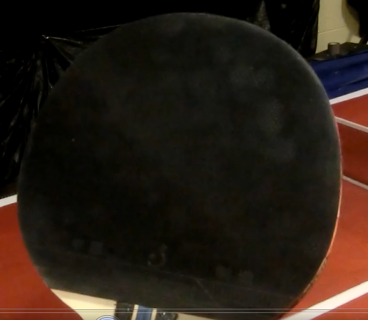
Racket 1 (Figure 12.1):

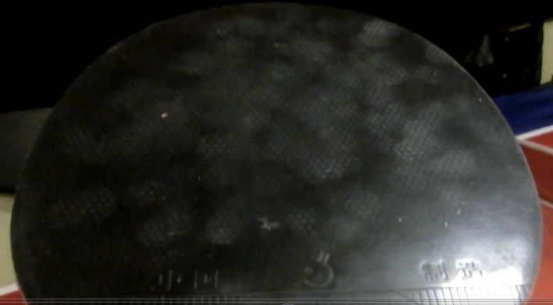
Racket 2 (Figure 12.2):

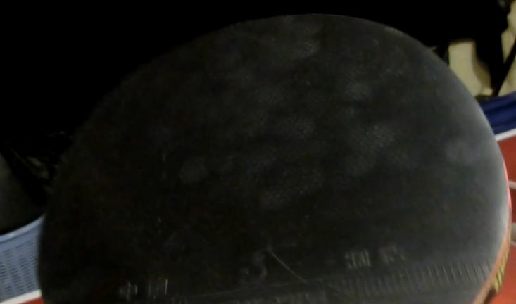
Racket 3 (Figure 12.3):
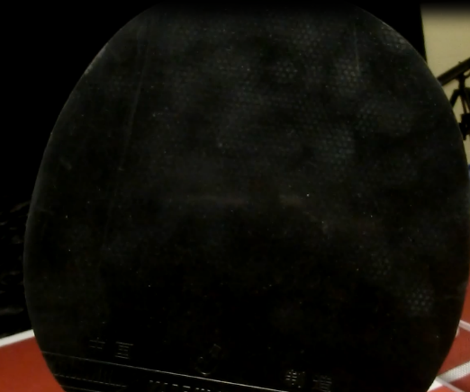
Racket 4 (Figure 12.4):
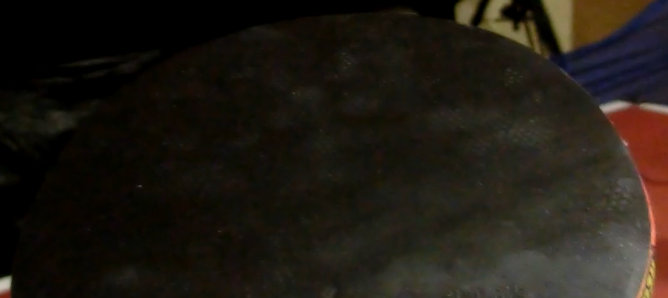
Racket 5 (Figure 12.5):
See howspinworks.weebly.com/part-2.html to see higher resolutions of these pictures.
Discussion:
As made evident in Table A10, Racket 3 retained more spin than racket 2. This is likely due to the fact that Racket 2 had dust that had accumulated over the time it took to play 500 shots (50 each week), that was still there, whilst Racket 3 had 10 weeks’ worth that had been removed, thus there was less dust on it. By the observations made after the final tests and during the 50 shots every week, Racket 1 felt significantly better to play with, while Rackets 2 and 3 felt slightly inferior, but the two could not be distinguished through playing alone. Racket 4 (control) had much less spin, and Racket 5 was as slippery as glass, though at times felt as though it was faster (due to the hardening of the rubber from the UV rays).
The difference on this low-level competitive equipment is noticeable, but nowhere near as significant as it is on expensive equipment used for high-level play, for there is less spin to lose. Figure 6 suggests that cleaning and storing method does not have a large effect on power, but Figure 5 shows that spin is greatly affected. Racket 5 has shown that sunlight has a detrimental effect on spin.
As shown in the Racket Photo Comparison table (Table 2), the bats have varying amounts of dust on them. Figures 12.1 and 12.3 show that Rackets 1 and 3 have significantly less dust on them, meaning that the cleaning method is effective in removing dust, whereas Figures 12.2 and 12.4 show that Racket 2 and 4 both have large amounts of dust on them. The amount is visually similar, but the results show that Racket 2 has a slight spin and power advantage over Racket 4. This is due to the fact that Racket 2 was in a case, but the photos provide evidence to suggest that after ten weeks of play, the amount of dust gathered from sitting outside of a case is little more than what is already on the rubber due to play.
Racket 5 spent a total of approximately 70 hours subject to sunlight (through a window) (1 hour a day, for 70 days). The results have shown that sunlight has a substantial effect on spin, but has a lesser effect on power. The ultraviolet light destroys the rubber, with a longer period of time subject to the light causing greater reduction of playing characteristics. This is known as UV degradation. This causes the rubber to break down much faster than it would through ordinary use. The topsheet was noticeably slipperier than the other rubbers, thus it is reasonable to conclude that this is what reduced the spin.
Figure 4 shows that cleaning a racket and keeping it in a case is the best method for preserving power by a significant margin. The difference between cleaning a racket and keeping it in a case is not significant (and likely would not be noticed during play) until at least six weeks have passed, when cleaning the racket preserves power better than keeping it in a case; a trend that would likely only become more significant over longer periods of time. Figure 4 also shows that cleaning the racket, keeping it in a case, or doing both is most more beneficial than doing none of those by a significant margin. However, it is shown that not cleaning a racket over a period of one week, but keeping it in a case will not allow the racket to collect enough dust to cause a significant reduction in power. It is shown that not cleaning or keeping the racket in a case reduces power greatly, and leaving a racket in sunlight reduces that power further, though not to the degree that sunlight affects spin, as represented in Figure 5.
Figure 5 shows that spin is affected by cleaning and storage much more than power is. In the space of a week, there is not a large difference between keeping a racket in its case, cleaning it or doing neither, however, doing both is clearly very beneficial even over a short space of time. Figure 5 suggests that going for three or four days without cleaning a racket will not have a significant effect on spin, but the longer it goes, the more dust will build up, and this effect can be noticed within a week. It should be noted that after an initial rapid reduction in spin, Racket 4 (control), which was neither cleaned, nor kept in a case, had a slowing reduction in spin, potentially due to the amount of dust on the racket having a lesser effect as the amount increased. That is to say, there is such a large amount of dust already on the racket, that any further dust will have a much lesser effect.
Sunlight has an extreme effect on spin, especially compared to the already significant reduction in power. After the first week in the sun (approximately 7 hours), Racket 5 suffered a decrease of 4.7°, compared to the control racket’s 1°. This rate of reduction slowed rapidly to the point where there was no reduction in Week 8 to Week 9, and only 0.1° between Week 9 and Week 10. The effect of sunlight on spin is very clear – it reduces spin very quickly. That being said, this method could be used as a way to intentionally reduce the spin of an anti-spin or pimples-out (although this is against the rules), as a further experiment.

Conclusion:
The evidence proves that cleaning a table tennis racket and keeping it in a case will significantly preserve its power and spin, and that leaving a racket in the sun severely reduces both spin and power. My hypothesis is therefore correct. However, my prediction that keeping a racket in a case is more effective than cleaning it was incorrect.

Evaluation & Journal:
I feel that this experiment has greatly improved on How Spin Works Part 1, in that I feel the procedure and therefore data is much more accurate and scientifically valid. I also feel that this experiment is much more relevant to society than How Spin Works Part 1, as this is a problem that all competitive table tennis players encounter, and one that many recreational players may come across. There were no issues encountered during the investigation itself (during data collection), however the temporary loss of data (Week 2 to 7) due to the crashing of my computer was a major roadblock in the analysis of data. While I was still able to evaluate my hypothesis based off these results, the extra data provided much more information as to when the rubbers stopped noticeably decreasing in their playing characteristics, and at which points they were most affected by the cleaning and storage.

References and Acknowledgements:
Bailey, J. (2016). How Spin Works - Enhancing Table Tennis Rubbers. [online] Things that Affect Spin. Available at: http://howspinworks.weebly.com/things-that-affect-spin.html [Accessed 6 May 2016].
Bailey, J. (2016). How Spin Works - Enhancing Table Tennis Rubbers. [online] Speed and Spin off the Rubber. Available at: http://howspinworks.weebly.com/speed-and-spin-off-the-rubber.html [Accessed 6 May 2016].
Bailey, J. (2016). How Spin Works - Enhancing Table Tennis Rubbers. [online] How Spin Works. Available at: http://howspinworks.weebly.com/how-spin-works.html [Accessed 6 May 2016].
Bailey, J. (2016). How Spin Works - Enhancing Table Tennis Rubbers. [online] The Tests - Results. Available at: http://howspinworks.weebly.com/results.html [Accessed 6 May 2016].
"Haggisv", (2010). Hardbat Rubber Closeup (Figure 2). [image] Available at: http://ooakforum.com/viewtopic.php?f=47&t=12411 [Accessed 3 Apr. 2016].

Knorn, Florian. "Ball bouncing in slow motion: Squash ball." YouTube. YouTube, 14 Apr. 2013. Web. 26 Apr. 2014. http://www.youtube.com/watch?v=b1Ha7aKpIYs

Letts, Greg. “Spin in table tennis/ Ping-pong – How does it work and how do you create it?.” About.com Table Tennis / Ping-pong. N.p., n.d. Web. 24 Apr. 2016. http://tabletennisabout.com/od/spin/ss/spinworkcreat_4.htm
Nave, R. (n.d.). Bernoulli Effect. Retrieved March 3, 2016, from http://hyperphysics.phy-astr.gsu.edu/hbase/pber.html

“Pingpongkf”, (2006). Post your paddles (Figure 1). [image] Available at: http://mytabletennis.net/forum/forum_posts.asp?TID=5869&PN=2 [Accessed 16 Apr. 2016].
Qun, W., Zhifeng, Q., Shoafa, X. and Enting, X. (1992). Experimental Research in Table Tennis Spin. [online] ITTF.com. Available at: http://www.ittf.com/ittf_science/SSCenter/docs/199208013-%20Wu%20-%20Table%20Tennis%20Spin.pdf [Accessed 9 Apr. 2016].
`"Table tennis." Wikipedia. Wikimedia Foundation, 5 Jan. 2014. Web. 12 March 2016. http://en.wikipedia.org/wiki/Table_tennis
UV Degradation Mechanisms. (n.d.). Retrieved April 4, 2016, from http://www.drb-mattech.co.uk/uv degradation.html
UV Additives. (n.d.). Retrieved April 16, 2016, from http://www.drb-mattech.co.uk/uv additives.html

Appendix:
Week 1:
Table A1 | Racket 1 | Racket 2 | Racket 3 | Racket 4 | Racket 5
Power Test: | 201mm | 199mm | 202mm | 201mm | 200mm
Spin Test: | 27.1° | 26.8° | 27.0° | 26.9° | 27.1°
Week 2:
Table A2 | Racket 1 | Racket 2 | Racket 3 | Racket 4 | Racket 5
Power Test: | 199mm | 198mm | 196mm | 191mm | 188mm
Spin Test: | 27.0° | 26.0° | 26.2° | 25.8° | 22.4°
Week 3:
Table A3 | Racket 1 | Racket 2 | Racket 3 | Racket 4 | Racket 5
Power Test: | 196mm | 194mm | 193mm | 183mm | 180mm
Spin Test: | 26.8° | 25.3° | 25.7° | 24.9° | 20.3°
Week 4:
Table A4 | Racket 1 | Racket 2 | Racket 3 | Racket 4 | Racket 5
Power Test: | 193mm | 189mm | 188mm | 177m | 174mm
Spin Test: | 26.7° | 24.8° | 25.1° | 24.0° | 18.8°
Week 5:
Table A5 | Racket 1 | Racket 2 | Racket 3 | Racket 4 | Racket 5
Power Test: | 189mm | 184mm | 185mm | 171mm | 169mm
Spin Test: | 26.4° | 24.2° | 24.5° | 22.9° | 18.1°
Week 6:
Table A6 | Racket 1 | Racket 2 | Racket 3 | Racket 4 | Racket 5
Power Test: | 186mm | 178mm | 181mm | 165mm | 163mm
Spin Test: | 26.1° | 23.5° | 23.9° | 21.9° | 17.7°
Week 7:
Table A7 | Racket 1 | Racket 2 | Racket 3 | Racket 4 | Racket 5
Power Test: | 182mm | 172mm | 176mm | 162mm | 158mm
Spin Test: | 25.8° | 22.9° | 23.5° | 21.2° | 17.3°
Week 8:
Table A8 | Racket 1 | Racket 2 | Racket 3 | Racket 4 | Racket 5
Power Test: | 178mm | 166mm | 172mm | 159mm | 155mm
Spin Test: | 25.4° | 22.2° | 23.1° | 20.3° | 17.1°
Week 9:
Table A9 | Racket 1 | Racket 2 | Racket 3 | Racket 4 | Racket 5
Power Test: | 175mm | 162mm | 166mm | 156mm | 152mm
Spin Test: | 25.1° | 21.73° | 22.6° | 19.6° | 17.1°

Week 10 – final week:
Table A10 | Racket 1 | Racket 2 | Racket 3 | Racket 4 | Racket 5
Power Test: | 172mm | 157mm | 162mm | 153mm | 148mm
Spin Test: | 24.85° | 21.2° | 22.3° | 19.4° | 17.0°

Week 1 compared to Week 10:
Table A11 | Racket 1 | Racket 2 | Racket 3 | Racket 4 | Racket 5
Week 1 power | 201mm | 199mm | 202mm | 201mm | 200mm
Week 10 power | 172mm | 157mm | 162mm | 153mm | 148mm
Week 1 spin | 27.1° | 26.8° | 27° | 26.9° | 27.1°
Week 10 spin | 24.85° | 21.2° | 22.3° | 19.4° | 17.0°

Overall Power Results:
Table A12 | Racket 1 | Racket 2 | Racket 3 | Racket 4 | Racket 5
Week 1 | 201mm | 199mm | 202mm | 201mm | 200mm
Week 2 | 199mm | 198mm | 196mm | 191mm | 188mm
Week 3 | 196mm | 194mm | 193mm | 183mm | 180mm
Week 4 | 193mm | 189mm | 188mm | 177mm | 174mm
Week 5 | 189mm | 184mm | 185mm | 171mm | 169mm
Week 6 | 186mm | 178mm | 181mm | 165mm | 163mm
Week 7 | 182mm | 172mm | 176mm | 162mm | 158mm
Week 8 | 178mm | 166mm | 172mm | 159mm | 155mm
Week 9 | 175mm | 162mm | 166mm | 156mm | 152mm
Week 10 | 172mm | 157mm | 162mm | 153mm | 148mm

Overall Spin Results (degrees):
Table A13 | Racket 1 | Racket 2 | Racket 3 | Racket 4 | Racket 5
Week 1 | 27.1 | 26.8 | 27.0 | 26.9 | 27.1
Week 2 | 27.0 | 26.0 | 26.2 | 25.8 | 22.4
Week 3 | 26.8 | 25.3 | 25.7 | 24.9 | 20.3
Week 4 | 26.7 | 24.8 | 25.1 | 24.0 | 18.8
Week 5 | 26.4 | 24.2 | 24.5 | 22.9 | 18.1
Week 6 | 26.1 | 23.5 | 23.9 | 21.9 | 17.7
Week 7 | 25.8 | 22.9 | 23.5 | 21.2 | 17.3
Week 8 | 25.4 | 22.2 | 23.1 | 20.3 | 17.1
Week 9 | 25.1 | 21.73 | 22.6 | 19.6 | 17.1
Week 10 | 24.85 | 21.2 | 22.3 | 19.4 | 17.0

Power (a table tennis term), used in this context is the ability to apply a large amount of energy to a ball when it is struck, thus it is not the racket’s power, but indeed the amount of energy transferred back into the ball when it comes into contact (efficiency of restitution). The more energy transferred back into the ball, the more “power” or “speed” the racket has.
Like power, spin is not contained within the racket, and varies between players and equipment, but it is the ability to impart spin on a ball. The more spin that can be imparted on the ball, the more spin the racket is deemed to have.

